Note: The steps were tested using the Microsoft APAC Toll Free Number.

ESU MAK Key/Product Key: NPY7Q-MJ7BR-VGQDH-XB82Q-H2483

ESU Activation ID: c0a2ea62-12ad-435b-ab4f-c9bfab48dbc4

Before calling Microsoft, take note of the Installation ID.

To get the installation ID, run powershell as administrator and type the following commands:

1. Install the Windows 2012 ESU Year1 Product Key using “slmgr /ipk <ESU MAK Key/Product Key>”

cscript /Nologo "C:\Windows\System32\slmgr.vbs" /ipk NPY7Q-MJ7BR-VGQDH-XB82Q-H2483

1. Get the installation ID using “slmgr /dti <ESU Activation ID>”

cscript /Nologo "C:\Windows\System32\slmgr.vbs" /dti c0a2ea62-12ad-435b-ab4f-c9bfab48dbc4

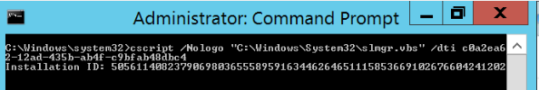

Group the numbers in the Installation ID by 7 digits as they will be requested by the IVR.

Sample Grouping:

5056114-0823790-6980365-5589591-6344626-4651115-8536691-0267660-4241202

Contact Microsoft by dialing the APAC Toll Free number below via Webex:

90080024681668

\*\*IF in USA, dial 888-352-7140

1. An IVR will answer and provide a security code. Take note of the code and input them using the Webex Keypad.
2. Once code is accepted, listen to the prompts and select the option that applies:

\*\*If using a smartphone to activate\*\*

* 1. Dial number with smartphone, repeat security code as prompted. Say “activation” and next prompt will be “Windows”. It will then ask if a text message could be sent to your phone. As shown below.

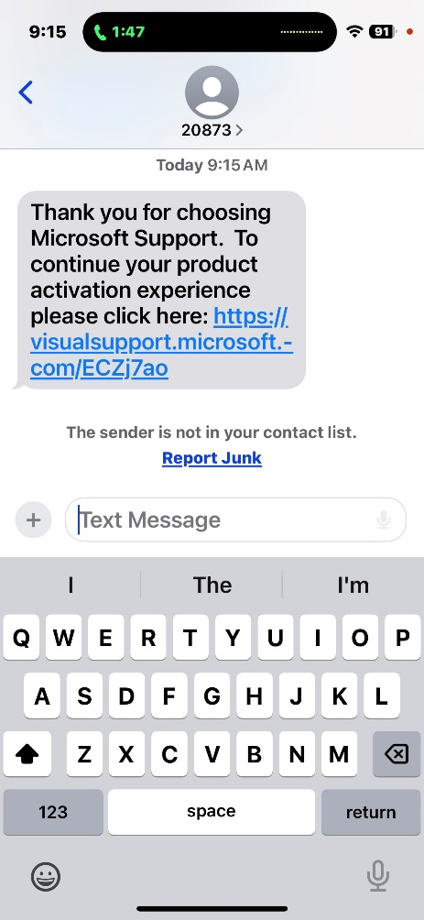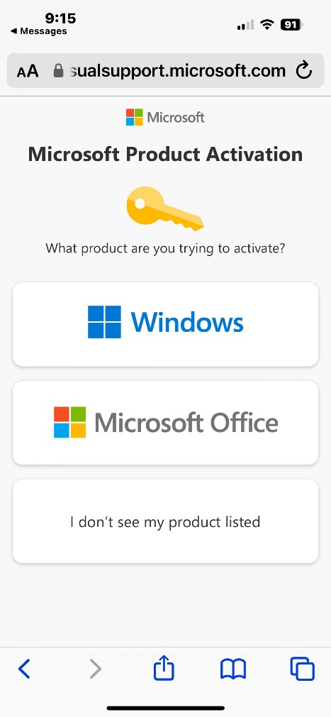

* 1. Click on link, select “Windows”.

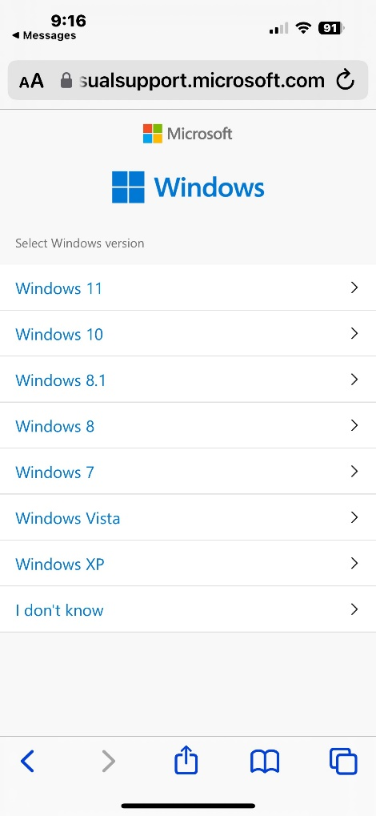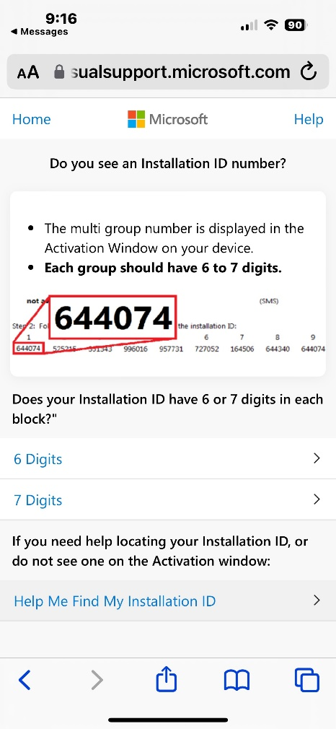

* 1. Select “I don’t know”, and then “7 Digits”

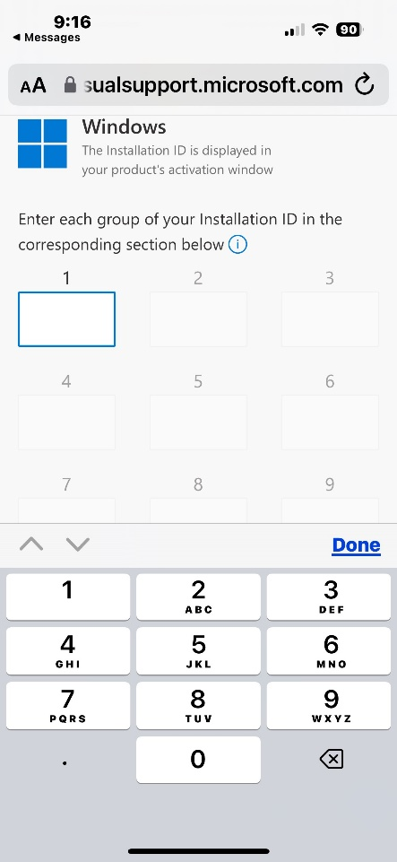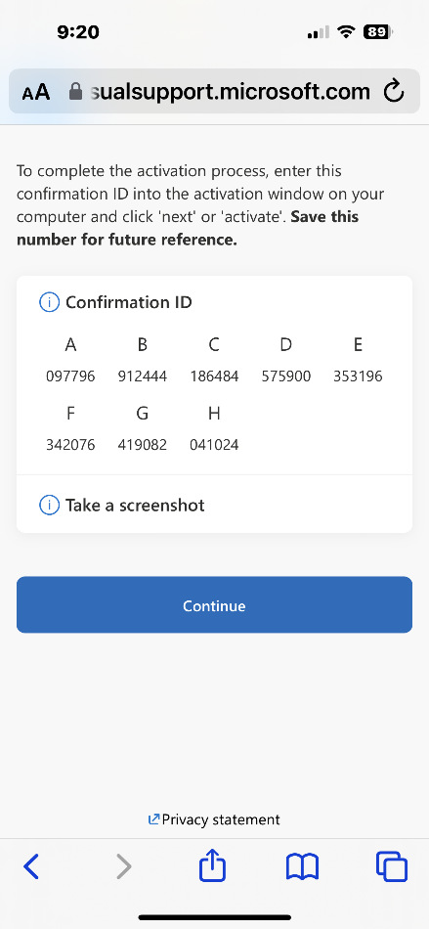

* 1. Enter installation ID, and next screen will provide the Confirmation ID.

Option 1 for Windows > Option 2 for Other OS > Option 1 to begin > provide installation ID by group as requested by the IVR.

1. Once done. Confirmation ID will be provided. Take note of the confirmation ID. Follow the options if you need to repeat or end the call once done.

Sample Confirmation ID:

527815-087724-245424-438956-214504-940890-450850-176321

1. Activate the ESU license using “slmgr /atp <Confirmation ID> <ESU Activation ID>.

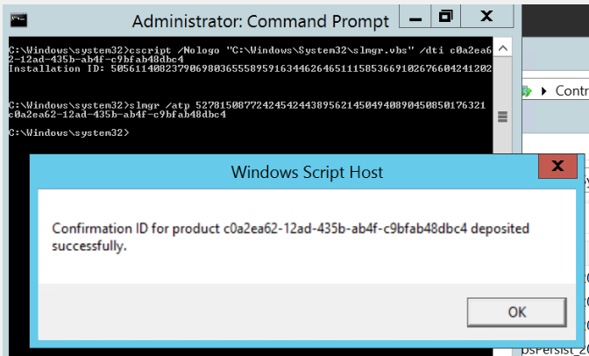

1. Verify that “License Status” shows as “Licensed” by typing “slmgr /dlv <ESU Activation ID>.

cscript /Nologo "C:\Windows\System32\slmgr.vbs" /dlv c0a2ea62-12ad-435b-ab4f-c9bfab48dbc4

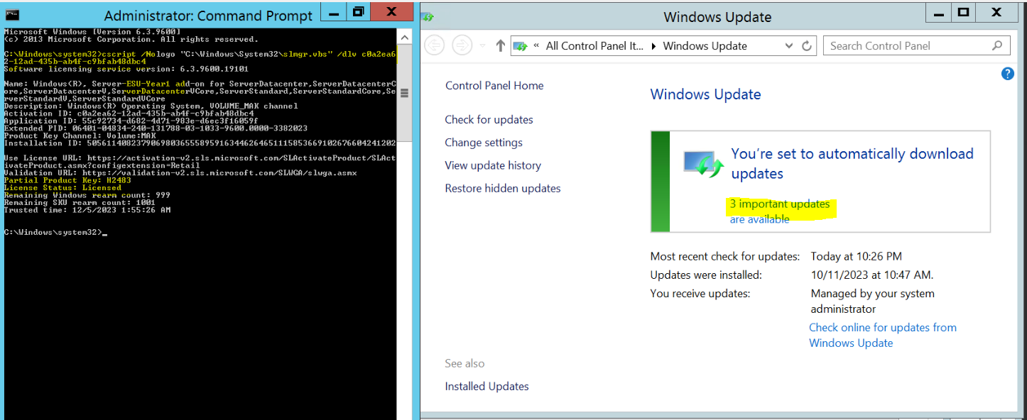

Thank you!